**RIPHAH INTERNATIONAL UNIVERSITY, ISLAMABAD**



**Lab 12**

**Bachelors of Computer science – 6th semester**

**Subject:** Artificial Intelligence Lab

**Submitted to:** Ma’am Ayesha

**Submitted by:** Munaza Malik

**Sap Id:** 44956

**Date:** 29th April, 2025

**Lab Tasks**

**Question 01:**

**SVM Algorithm:**

| **ID** | **Feature 1 (X1)** | **Feature 2 (X2)** | **Label (Y)** |
| --- | --- | --- | --- |
| 1 | 2.5 | 2.4 | 0 |
| 2 | 1.0 | 1.2 | 0 |
| 3 | 2.2 | 2.9 | 0 |
| 4 | 1.3 | 1.1 | 0 |
| 5 | 3.0 | 3.0 | 0 |
| 6 | 7.6 | 8.0 | 1 |
| 7 | 6.8 | 7.1 | 1 |
| 8 | 8.2 | 8.5 | 1 |
| 9 | 7.1 | 6.5 | 1 |
| 10 | 6.5 | 7.0 | 1 |
| 11 | 3.2 | 2.9 | 0 |
| 12 | 2.8 | 2.7 | 0 |
| 13 | 7.5 | 6.9 | 1 |
| 14 | 8.0 | 8.3 | 1 |
| 15 | 1.5 | 1.0 | 0 |
| 16 | 2.0 | 2.2 | 0 |
| 17 | 6.9 | 7.4 | 1 |
| 18 | 7.2 | 6.8 | 1 |
| 19 | 3.0 | 2.6 | 0 |
| 20 | 8.3 | 8.7 | 1 |

* Load the dataset into Python from a .csv file.
* Split it into training and testing sets (70% train, 30% test).
* Train an SVM model using kernel='linear'.
* Print the accuracy on the test set.
* Plot the data and the decision boundary.

**Solution:**

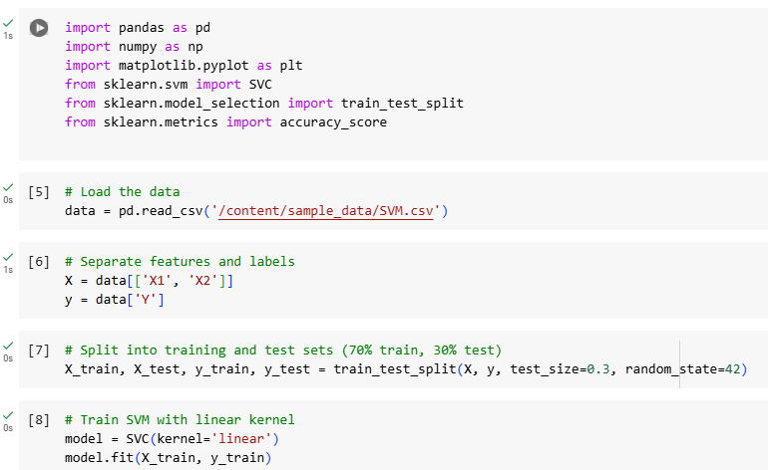 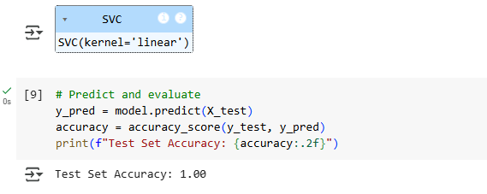 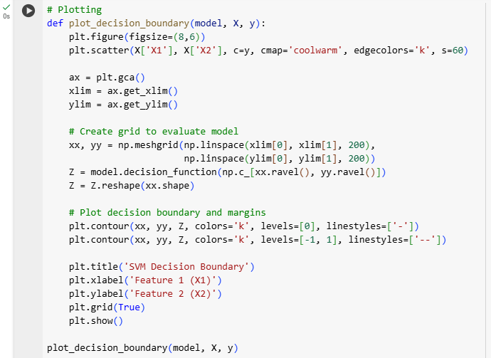

**Output:**

